Title of Invention: [type the title in less than 10 words in title case]

Inventors: [List down all inventors, seperated by asemicolon]

Type of Applicant: [Tick the selected type with the symbol√]
INDIVIDUAL SMALL ENTITY CORPORATE

Name of the Applicants: [please copy/paste the similar table, if want to add more applicants]
1 | Name | Bharatvaj PH
 | Address | 49/28a, Annai Theresa Nagar 10th Street, Puzhithivakam, Chennai - 600091
 | Contact Number | 8939086095
 | Email Address | bharatvaj@yahoo.com

2 | Name | Dinesh Kumar M
 | Address
 | Contact Number
 | Email Address | dineshmnaidu@gmail.com

3 | Name | Goutham SM
 | Address
 | Contact Number
 | Email Address | gouthamsm97@gmail.com

Address for Service: [please provide the address to which communication will be send fromIPO]
1 | Name
 | Address
 | Contact Number
 | Email Address

Abstract: [provide a brief description of the invention]
Internet of things aims to unify every devices under a single infrastructure. Transforming real world objects into virtual nodes that can be controlled by the user. WiFi was the de-facto standard for wireless technology for more than a decade for the internet. With growing number of wireless specifications such as Bluetooth, ZigBee, Thread, Z-Wave, etc. There is hardly any effort for having any compatibility between them to achieve this unified behavior. Further, even though ZigBee and Z-Wave are mostly targeted towards IoT. It does not solve the compatibility problem. And also there will be no wireless technology which is perfect for every use case. Hypothetically speaking even if there is a perfect wireless technology, there is always “The Hipster Effect”(Jonathan Touboul, 2014).By introducing an adapter, we can solve this issue by connecting nodes operating in different wireless specifications

I. Specifications: [Explain the invention in sufficient detail]

1. Describe the Novel Feature: [Explain what is new or novel in the invention with the description of the problem and an outline of the solution]

2. Drawbacks of the existing state-of-art and how the drawbacks have been overcome and advantages of your invention

1. Brief Description of Figures:
TYPE OF FIGURES [please add according to our invention]
TYPE 1 -Block diagram or schematic diagram of all components or Process Diagram;
TYPE 2 - Component-specific block diagram or circuit diagram;
TYPE 3 -Results in the form of graphs/tables/charts;
TYPE 4 - If the invention has scope for alternate or additional embodiments, kindly outline the digrams;
TYPE 5 – Block diagram or schematic diagram presented in alternate views;
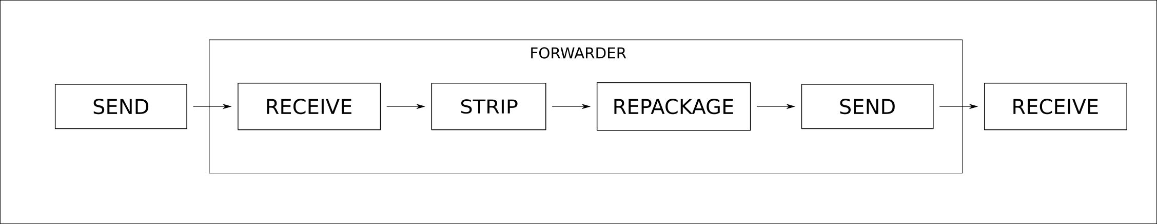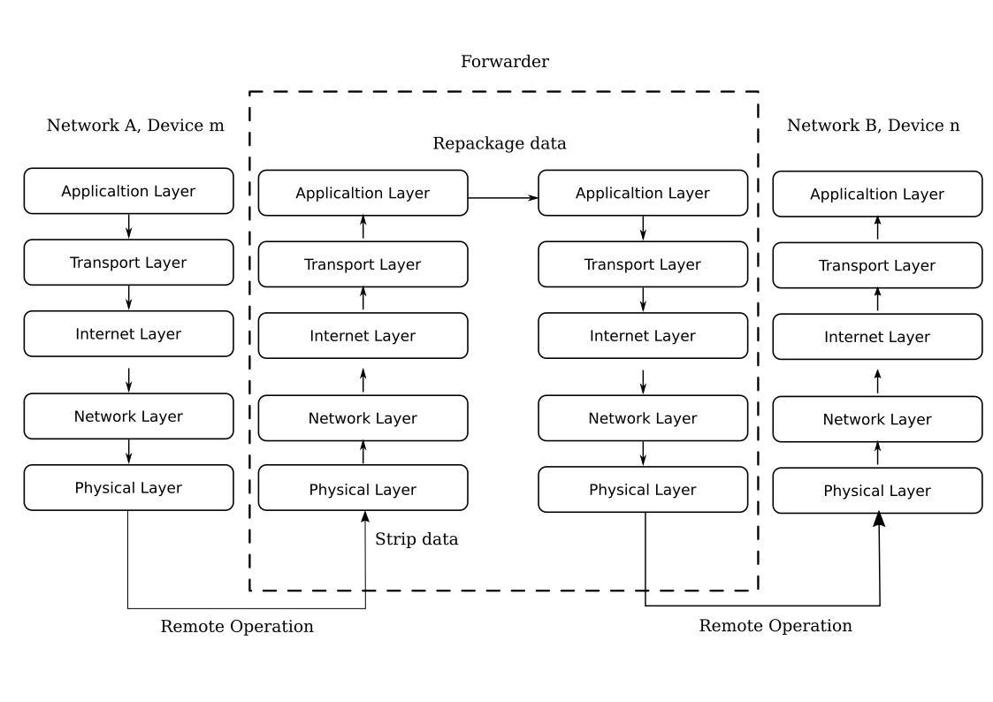

III. Detailed Description

THE INVENTION OUTLINE [Block Diagram of all components or Process Diagram]
[The full construction of the invention in terms of Input, components, process and output. Explain each section in the context of the presented figures and name all components/process by numbers for eg 1,2,3…]
The `adapter` is collectively the software `modules` and hardware required to convert relay messages from one network to another.
There are two phases in the working of adapter.
Phase One - Setup of Adapter
- Detect - Detects hardware of the adapter
- Select - Out of the detected hardware, user choose the hardware to use
- Bind - User tells the adapter that the request of the a specific network to should be forwarded to the specified network
Phase Two - Adapter connection process
- Listen - Adapter listening on network, so that other devices can connect to adapter
- Connect - Adapter connects to a specific host
- Forwarder - The connection is retransmitted according to the bind

SPECIFIC COMPONENTS EXPLAINED

[If any of the component(s) or hardware(s) warrant specific description with the help of figures, kindly describe them in detail]
Detect(1)
Forwarder supports various network technologies and also new network technologies can be added by adding the corresponding module. But due to cost and requirement, only some of the networks are actually needed. Detection of hardware devices are performed to load the corresponding software modules. For instance, in a adapter with a WiFi and a Bluetooth hardware loading extra modules such as ZigBee and ZWave will only slow the adapter.
Select(2)
Even if the hardware component is present in the adapter. The power to use that component resides in software modules. This is controlled by the user of the adapter.
Bind(3)
Once the networks which are needed are selected. The individual devices which is needed to register with other networks are specified. This step should be done for each devices and for each network. (i.e) If there are N networks and there are D devices in each network. D devices in each network should be configured to work with other N-1 networks or as need by the user. Since this process is systematic, it can be easily automated by scripts or can configured by the user as needed. Thus providing convenience and flexibility.
Listen(4)
When a device is binded, the forwarder starts a listen instance. Whenever a bind is configured for a device with Network `A` to another device with Network `B`, Forwarder starts listening for `B` devices. When a device `C` tries to access `B`, connect instance of `A` is called.
Connect(5)
`A` is the device with true address, whereas the device `B` is pseudo. Connection to `A` is done with the forwarder.
Forward(6)
Adapter has the connection with `A` and `C`. This leaves us with stripping and repackaging
- Strip
The `message` is the data which is to reach the end system. Suppose `C` is the first one to send message to `A`. `C` sends the message to adapter. Adapter strips the `C` related network headers and network related encryption, and stores the message.
- Repackage
The message which is free of all the network headers and network related encryption, it is repackaged with `A` related network headers and encryption if any.

ALTERNATE EMBODIMENTS
[alternate methods/ways of achieving the end result without expanding the scope of the invention can be explained here]
None

EXPERIMENTAL RESUTS & GRAPHS
[all lab/simulation/experimental results in the form of graphs/charts/tables can be prestented here. Kindly explain the contents of each graph/chart/table with sufficient information]
None

APPLICATION AREAS
[List down all application areas where the proposed invention can be used]
- IoT
- Smart Home
- Automation
- Data Transfer

PUBLIC DISCLOSURE
[Did this invention details are published in any media by inventor or applicant himself before patent filing, if any please list down]
None

